Pride in Health + Wellbeing Membership Grant: Expression of Interest

Background
Pride in Health + Wellbeing is excited to offer service providers operating services commissioned by WA Primary Heath Alliance (WAPHA) the opportunity to apply for one of 12 memberships in Pride in Health + Wellbeing, intended to help smaller organisations and general practices provide more LGBTQ inclusive care. These memberships will allow organisations to not only review and upskill on their care for gender and sexuality diverse patients/service users but also to measure this change through the free annual Health + Wellbeing Equality Index (HWEI) benchmark and surveys.

Benefits
Successful organisations will be provided with Training Membership for Pride in Health + Wellbeing Membership.

3 online training modules

on demand Relationship Manager Support

1 x on site visit

2 hr tailored training/consulting

online access to member-only resources

2-minute audit of services and planning session

Community of Practice every 8 weeks

Annual HWEI benchmarking tool, staff survey, service user survey (with full report of results)

During this time, they will be provided with their own Relationship Manager, who will be their mentor and coach to better understand LGBTQ inclusive care, upskill the staff through consultation and training, access to member-only resources and the latest research and best practice. Together the successful organisation will review their current inclusion and identify gaps in inclusive care across the service user lifecycle.

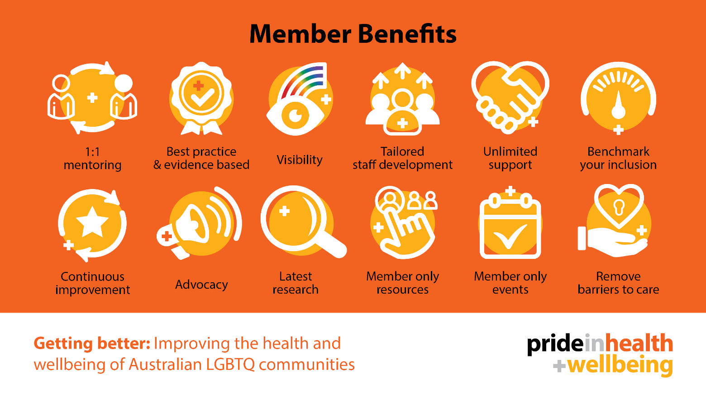
Key Dates
- 01/07/2022 - EOI opens
- 01/10/2022 - EOI closes (now extended)
- 10/10/2022 - Successful applicants notified via email
- 10/10/2022 - Membership begins
- 10/10/2023 - WAPHA funded membership ends

Further questions:
Please contact Pride in Health + Wellbeing at Info@PrideinHealth.com.au
Or visit our website Prideinhealth.com.au/grants

This activity is supported by funding from WAPHA through the Australian Government’s PHN Program.

PIHW Membership-
EOI Application 2022

Organisation

Contact Person

Email

Phone

Website

Address

Please describe your organisation and what you do:

Your Full Time Equivalent (EFT) number of employees: ____________________________

Please return to Pride in Health + Wellbeing via email to info@prideinhealth.com.au by the closing date.

By sending in this application, you agree to have your organisation’s details shared with WAPHA to administer this grant. You also agree to participate in the Pride in Health + Wellbeing program, and its annual benchmarking process.

