Coles Grant: Expression of Interest

Background
Through the generosity of Coles, two 2-year Pride in Health + Wellbeing standard Memberships are available to help smaller organisations provide more LGBTQ inclusive care. These memberships will allow these organisations to not only review and upskill on their care for gender and sexuality diverse patients/service users but also to measure this change through the free annual Health + Wellbeing Equality Index (HWEI) benchmark and surveys.

Criteria
These two memberships will be awarded to organisations that meet the following criteria:
- Less than 25 FTE
- Be a not-for-profit organisation
- Working in the health, wellbeing or human services sector
- Working with vulnerable, marginalised and minoritised communities (e.g. Culturally and linguistically diverse communities, Refugee and newly arrived communities, those impacted by domestic, family and intimate partner violence, people living with a disability, Aboriginal and Torres Strait Islander Communities, regional and remote communities etc)
- Are located outside a capital city
- At least one is for an Aboriginal or Torres Strait Islander focused organisation.

Benefits
The two successful organisations will be provided with Standard level Pride in Health + Wellbeing Membership for 2 calendar years.

During this time they will be provided with their own Relationship Manager, who will be their mentor and coach to better understand LGBTQ inclusive care, upskill the staff through consultation and training, access to member-only resources and the latest research and best practice. Together the successful organisation will review their current inclusion and identify gaps in inclusive care across the service user lifecycle.

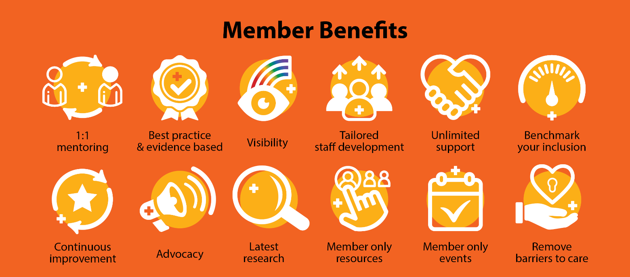

A full list of member benefits can be found in the Member benefits table: https://www.prideinhealth.com.au/membership/member-benefits/

Key Dates

01/05/2022 - EOI opens

01/06/2022 - EOI closes

10/06/2022 - Successful applicants notified via email

10/06/2022 - Membership begins

10/06/2024 - Coles funded membership ends

Reporting

Successful applicants will be introduced to the Coles Diversity and Inclusion (D&I) team to establish a professional relationship of support and mentoring. Connection to the nearest Coles store will also be established so that a local geographic support network can also be set up.

Successful applicants will be required to meet with the Coles D&I team quarterly, to discuss progress, look at opportunities to partner and work together, and get support and advice not only from Pride in Health + Wellbeing but also from the Coles team.

Coles team can provide support on:
- Networking
- Setting up an ally group
- Engaging executive allies
- and more

Further questions:
Please contact Pride in Health + Wellbeing at Info@PrideinHealth.com.au
Or visit our website Prideinhealth.com.au/grants
Coles Grant –
EOI Application 2022

Organisation

Contact Person

Email

Phone

Website

Address

Please describe your organisation:

Please select which communities you specifically serve:

☐ Aboriginal and/or Torres Strait Islander communities

☐ Rural and remote communities

☐ Refugees and recently arrived communities

☐ Communities impacted by violence (domestic, family, or intimate partner violence)

☐ People living with a disability

☐ People impacted by homelessness

☐ Another Community- please specify:

Why does your organisation want to be more LGBTQ inclusive?

Please return to Pride in Health + Wellbeing via email to info@prideinhealth.com.au by the closing date.

By sending in this application, you agree to have your organisation’s details shared with Coles to administer this grant. You also agree to participate in the Pride in Health + Wellbeing program, and its annual benchmarking process.

